Multivariate Analysis
• Correlation and Covariance
• Cross-tabulation
• Cluster Analysis, MANOVA(Multivariate Analysis of Variance), Factor and Canonical Correlation Analysis

Covariance and correlation are the two key concepts in Statistics that help us analyze the relationship between two variables.
Covariance measures how two variables change together, indicating whether they move in the same or opposite directions.
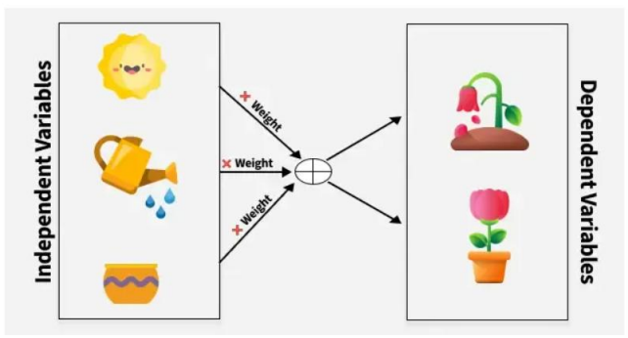
To understand this relationship better, consider factors like sunlight, water and soil nutrients (as shown in the image), which are independent variables that influence plant growth our dependent variable.
Covariance measures how these variables change together, indicating whether they move in the same or opposite directions.

What is Covariance?
Covariance measures how two random variables change together. It is calculated by averaging the product of their deviations from their means.
A positive value means they move in the same direction, while a negative value means they move in opposite directions.
It can take any value between - infinity to +infinity, where the negative value represents the negative relationship whereas a positive value represents the positive relationship.
It is used for the linear relationship between variables.
It gives the direction of relationship between variables.

What is Correlation?
Correlation is a standardized measure of the strength and direction of the linear relationship between two variables.
It is derived from covariance and ranges between -1 and 1. Unlike covariance, which only indicates the direction of the relationship, correlation provides a standardized measure.

• Positive Correlation (close to +1): As one variable increases, the other variable also tends to increase.
• Negative Correlation (close to -1): As one variable increases, the other variable tends to decrease.
• Zero Correlation: There is no linear relationship between the variables.

